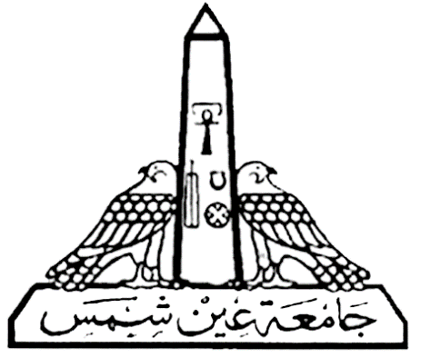

**Ain Shams University**

**Faculty of engineering**

**Computer and Systems Department**

**Compilers**

***Report on: Parser***

**Name: Mohamed Gamal Elsaid  
Name: Mohamed Osama Mostafa**

**Name: Mohamed Gamal Abbas  
Section: 3**

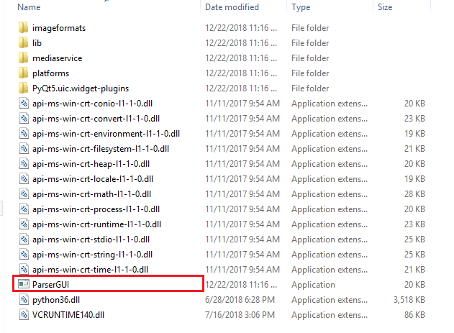To run project, click here

Write code and press parse

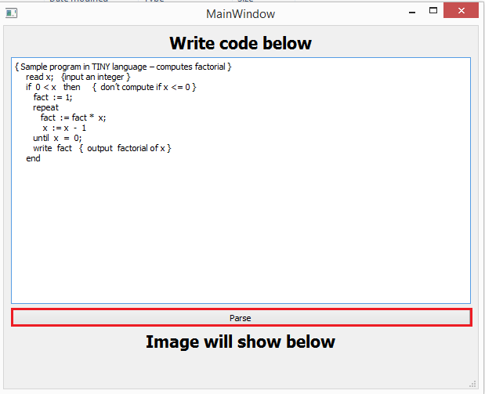

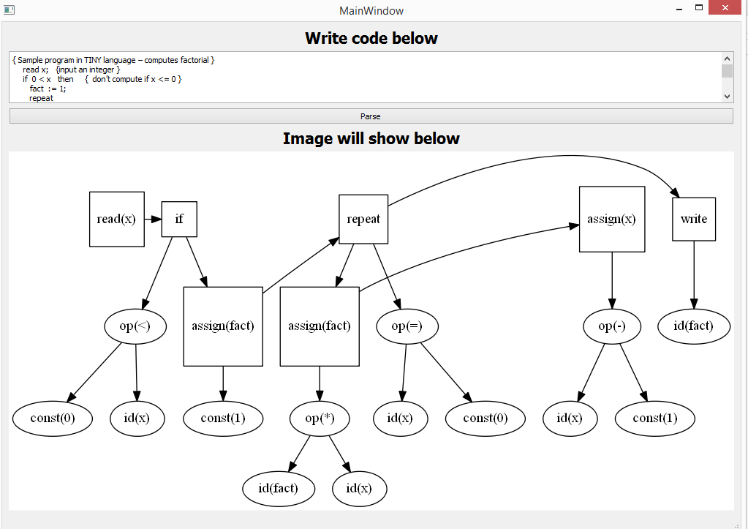Image will appear

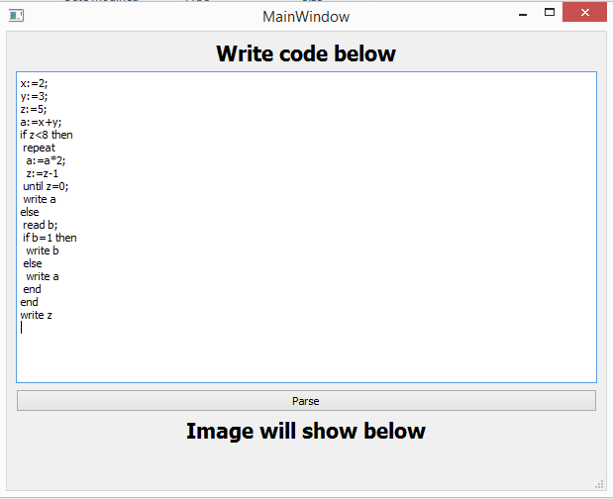Another testcase

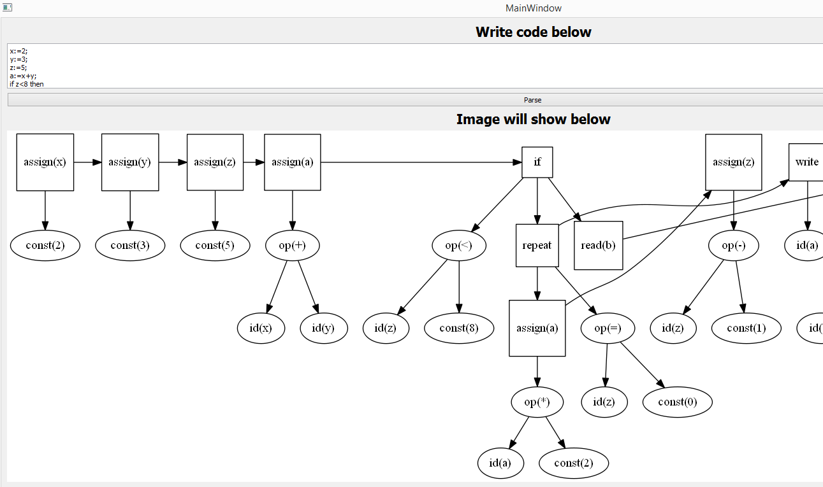

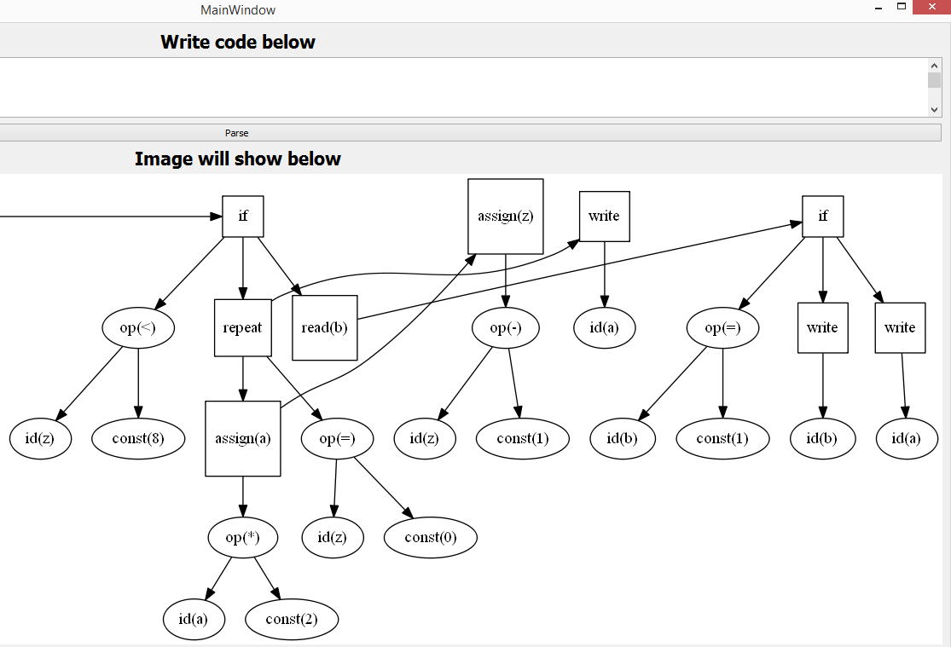

Notes

1-if u want to run another example you have to close exe and run it again

2-we changed second given example because we didn’t cover it we changed:-

a:= x+y+z; -----> a:= x+y;

write b*(x+y) -----> write b

3- if picture is too big it will go out of boundries like second testcase